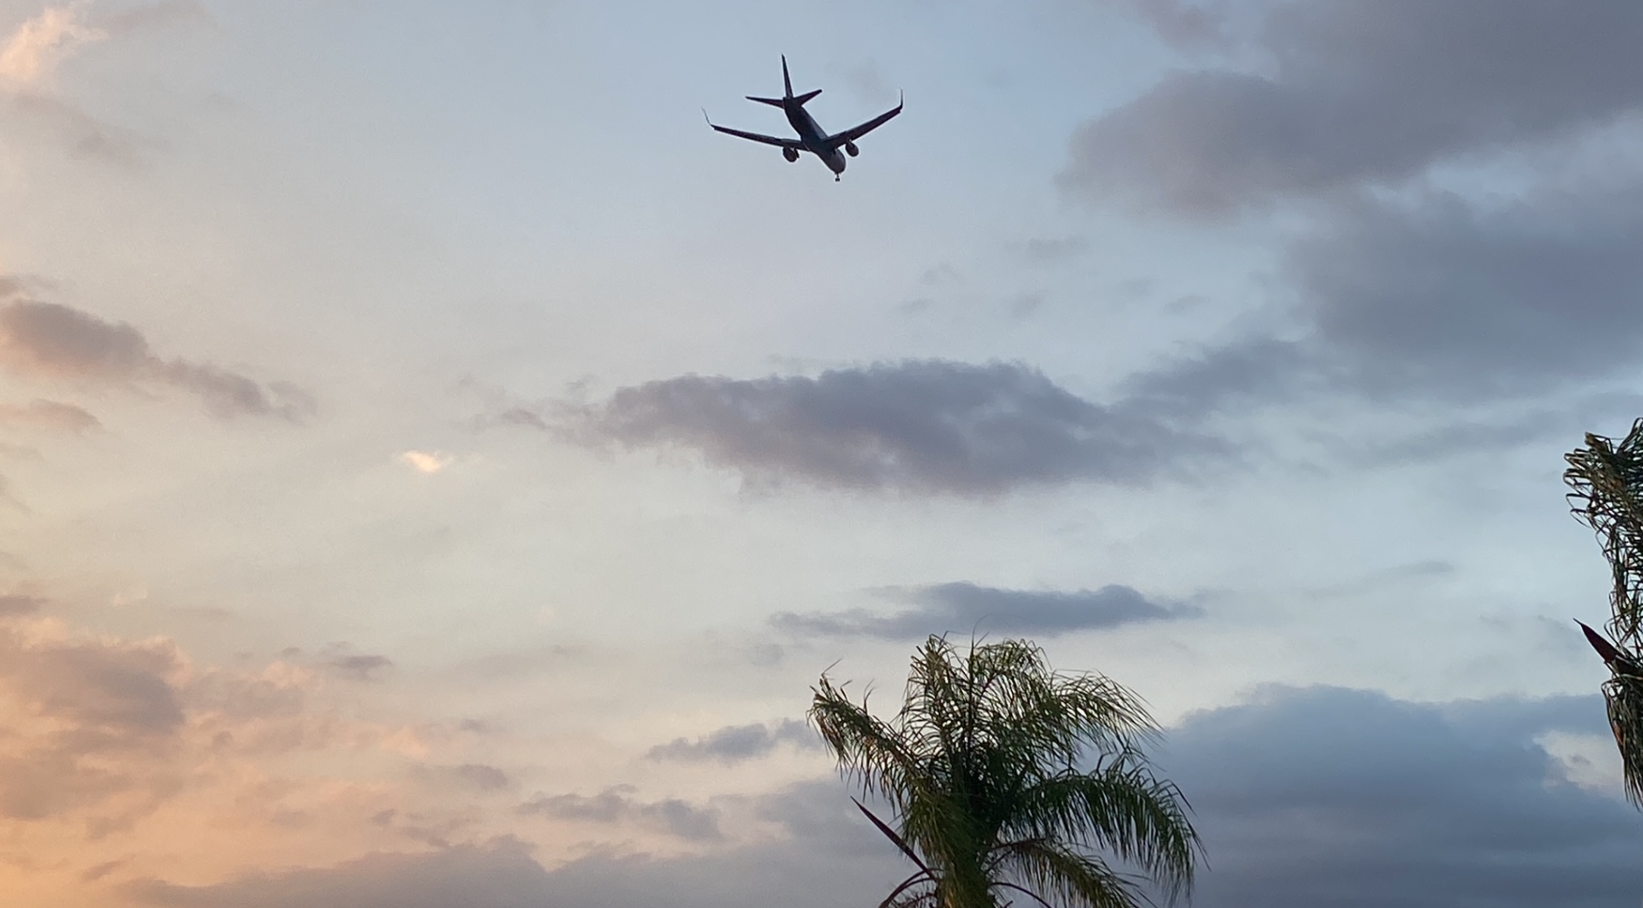

Here is the link to tonight’s REI overflight. Directly over REI at 2400'
https://flightaware.com/live/flight/ATN3521
I filed a NASA report too. It's attached to this email. Check out the photos taken by a REI pilot. They went to RAL FSDO as well.

