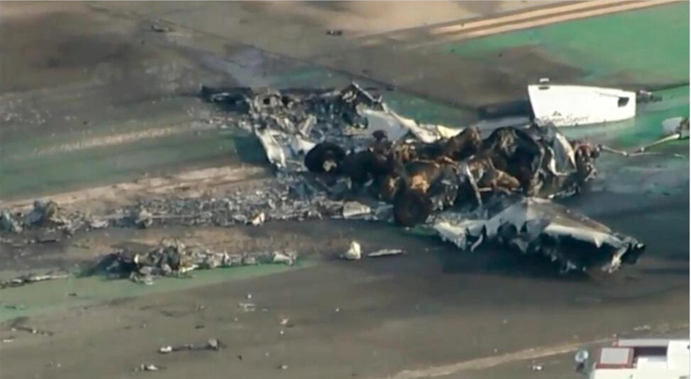
PHOTO: ASSOCIATED PRESS

Introductory Flight Lesson
Instructor / Student
2011 Piper Sport N126WK
9/8/2022
Santa Monica Airport

The flight path was northwest and then returning to Santa Monica Airport

Voice is heard on the sound recording obtained from

“LET GO!” is heard on the recording.

LISTEN to PILOT/CONTROLLER BY CLICKING HERE

