UPS Tests Approaches to SBD Rwy 24
On August 30th, UPS tested three approaches they are developing to access the freight business at SBD. These approaches included RNAV (GPS) Instrument Approaches to Runways 6 and 24 and an RNAV Visual Approach to Runway 24. The Runway 24 RNAV Approach is an instrument approach that requires special equipment and training because of the terrain near SBD. The Runway 24 RNAV Visual Approach can only be flown in visual conditions with the required equipment.

RNAV Visual Approaches are also known as a RVFP (RNAV Visual Flight Procedure). They are in use but not common. According to a FAA official these types of approaches are typically developed by a lead carrier such as UPS and can be shared with other carriers without restriction.

UPS personnel discussed their efforts to develop these approaches at RAA meetings in April 2018, September 2020, and March 2021. UPS was proactive in communicating their plans as the approaches being developed for SBD runway 24 were in close proximity to REI’s fixed wing traffic pattern.

UPS personnel were also kind enough to communicate their intention to flight test the approaches in April 2018, June 2019, and this most recent test on August 30, 2022. Why so many tests? Approaches are revised during development. Especially when they are in an area with significant terrain and adjacent to a traffic pattern at an uncontrolled airport (REI). They were also revised to address concerns voiced by Safety Risk Management Panel convened by the FAA’s Air Traffic Organization in February 2021. The most recent revisions included changes to the approach (path and altitude) to minimize risks. UPS utilized 767 aircraft to fly all of these tests.

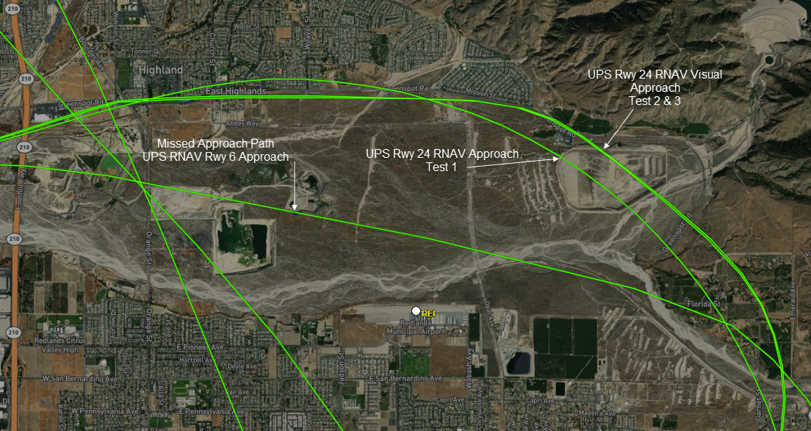
Copied below is a screen shot of the UPS 767 flight path near REI on August 30th copied from FlightAware.

The first flight test performed was the Rwy 24 RNAV approach which was closer to REI. The 2nd and 3rd approaches are the Rwy 24 RNAV Visual Approach. The flight paths were virtually identical. The UPS pilot was VFR and there was considerable traffic at REI. There were no radio calls to the REI CTAF during the test. The RNAV Visual approach (the second and third test approach) would provide the greatest clearance from most aircraft in the REI traffic pattern. There are still wake turbulence concerns. These concerns could be addressed if these operators inbound to SBD could make a radio call on the REI CTAF when they are inbound.

You can view the entire flight path of this test at this link:
FlightAware Flight Tracking Map United Parcel Service #9100

Over the last year we have seen heavy jets overflying REI because there has not been a charted approach into Rwy 24 at SBD. A charted approach to SBD Rwy 24 for heavy jet and high-performance aircraft provides a predictable path and is a much safer alternative than standard visual approaches or circle top land approaches.

It’s imperative for the FAA to require operators of heavy jets and high-performance aircraft landing on Rwy 24 at SBD, who need approaches outside of SBD Class D to use the new Rwy 24 RNAV Visual Approach when its available. We also need the FAA’s assistance to get these same operators to make a call on the REI CTAF when they are inbound.

Ted Gablin
President, Redlands Airport Association
Chapter of California Pilots Association

