Independent Comment:

It would seem the FAA does not have a final say on this. and since it’s off-airport the city can approve it. Because it may desire to support Relativity’s business needs, should the possible unintended consequences be discussed?

The community would no doubt appreciate understanding that the FAA would then have to adjust flight patterns to maintain safety distances. Those might then extend out into the community. Hence, should the city approve the project it would possibly force aircraft and helicopter operations elsewhere away from their current locations.

Over the last 5-plus years, the LGB helicopter community has worked hard to mitigate community impacts from helicopters. One might wonder if by approving the Relativity project new community impacts would be created.

Story:

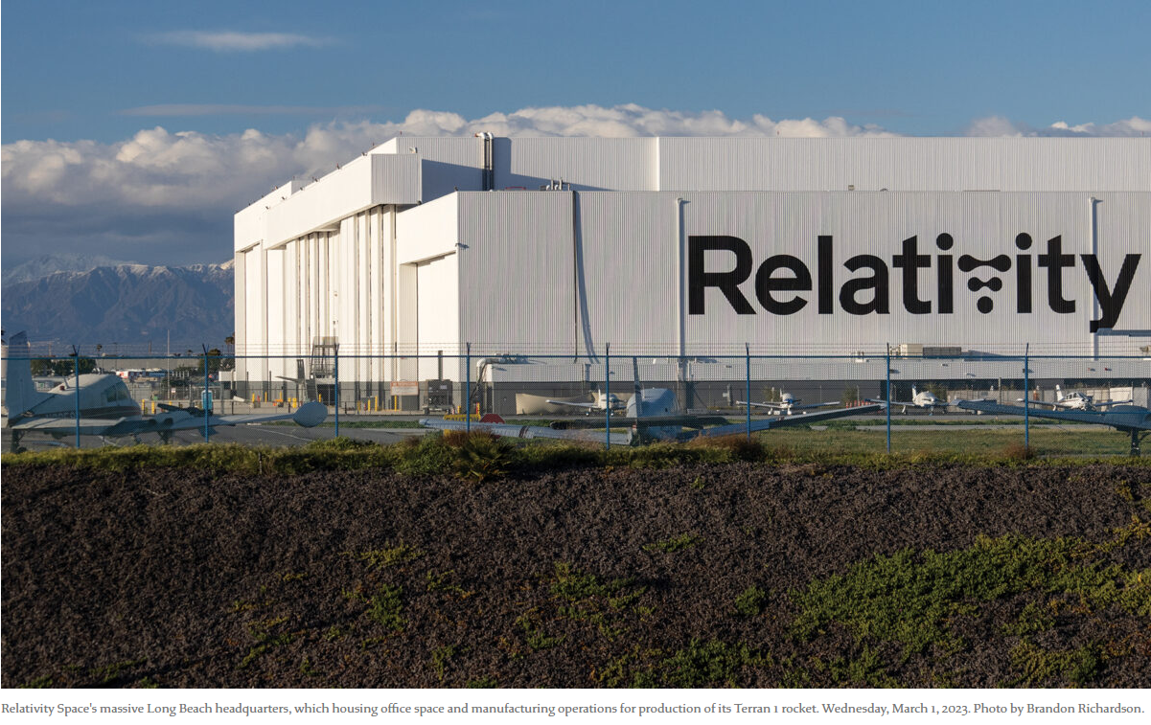
“Launch service provider Relativity Space has proposed the construction of a 200-foot-tall “test stand” at its headquarters adjacent to Long Beach Airport at the former C-17 site — something that’s been met with resistance from some aircraft operators.
It’s unclear exactly what the structure will look like or what tests will be conducted. Relativity did not respond to multiple requests for comment regarding the proposed project.
Based on coordinates submitted to the Federal Aviation Administration, the structure at its base will be roughly 41 feet by 79 feet between the airport property and the massive hangar that is now Relativity’s headquarters and manufacturing plant.
Staff from the city’s Economic Development, Community Development and airport departments are talking with Relativity about the project, but no formal building permit application has been submitted to the city,...” Finish reading Here.

