TORRANCE CITY COUNCIL HAS ACTED AGAINST GA

- IMPOSING LANDING FEES
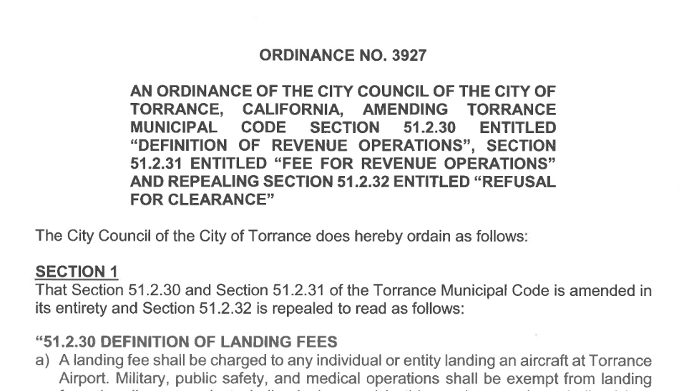

READ THE ORDINANCE HERE

- RUNWAY USE RESTRICTIONS
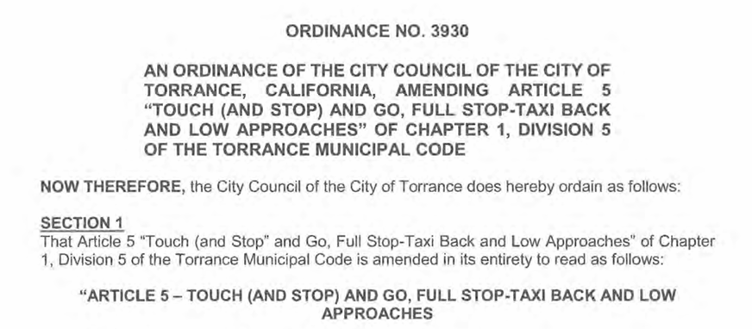
READ THE ORDINANCE HERE

- NOISE ABATEMENT GUIDE

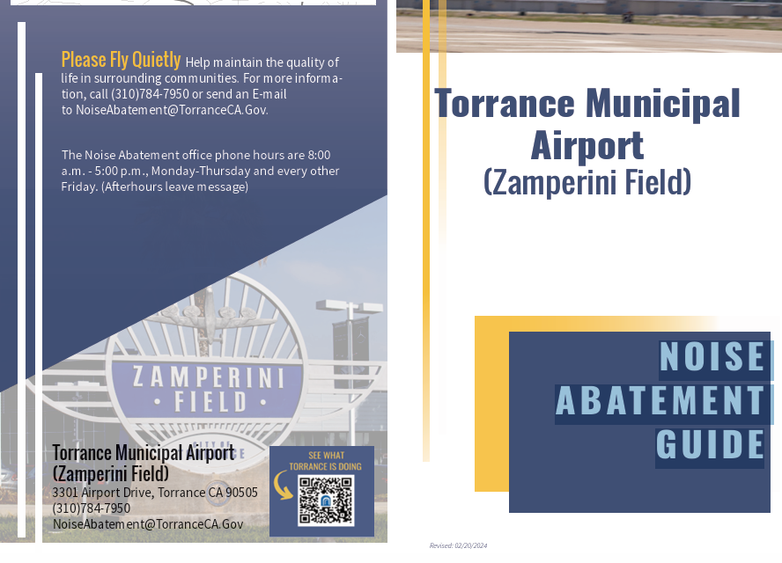

SEE THE ENTIRE GUIDE HERE

