Sent to SCAUWG.ORG by Wayne. Video Images captured by Ed Whistnant Aviation

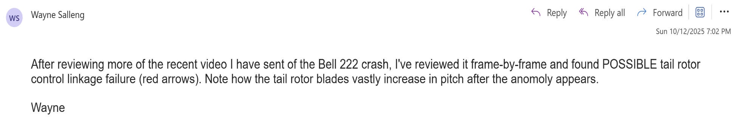

SCAUWG.ORG Editor: Possible Explanation

“Tail rotor failed. TR stopped as the helicopter came to high hover on approach about the palms.
Appears he tried to lift if about the trees which compounded the torque and started the
aggravated spin then lost control” ...TL

Published Comments on YouTube:


@e5toro7008
1 day ago
We were there. It made a loud whining noise just before it lost control and smoke was visible from the rotor before parts
detached, flew off, and the copter crashed below.
34
Reply
6 replies

@encinobalboa
1 day ago
Palm tree cushioned impact. Without the palm, copter would have pancaked. Passengers were very lucky.
23
Reply

@KennardJohnson-k7f
1 day ago
Tail rotor gear case came apart, you can see the fluid blowout.
23
Reply

Possible Tail Rotor Control Linkage Failure – Marked by Re Arrows – Analysis by
Wayne Salleng, aviator and historian
