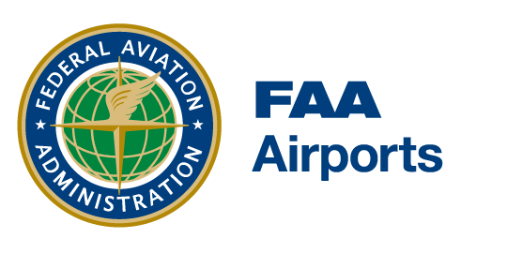
Dear Industry Colleague,
We recently added the following to the Draft Airports Advisory Circulars page on the FAA website:
DRAFT AC 150/5210-13D, Airport Water Rescue Plans and Equipment
Comments are requested by April 30, 2026. Please visit the webpage to access the draft AC and read procedures for submitting comments.

Thank you,
FAA Office of Airports

