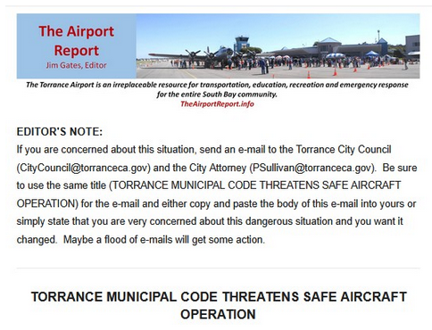

Plus: Visit the SCAUWG.ORG Torrance Airport Page
for News and Background information

CLICK HERE

